UIT UNIVERSITY

CSC-318 – Mobile Application Development LAB 7: Animation in Flutter II

Name

: Abdul Rehman

Roll No

: 22sp-052-cs

Section

:

Semester

:

FALL 2024

COMPUTER SCIENCE DEPARTMENT

import 'package:flutter/material.dart';

import 'package:flutter/scheduler.dart';

void main() {

  runApp(const MyApp());

}

class MyApp extends StatelessWidget {

  const MyApp({Key? key}) : super(key: key);

  @override

  Widget build(BuildContext context) {

    return MaterialApp(

      title: 'Hero Animation Demo',

      theme: ThemeData(

        primarySwatch: Colors.blue,

      ),

      home: const HeroAnimationScreen(),

    );

  }

}

class HeroAnimationScreen extends StatelessWidget {

  const HeroAnimationScreen({Key? key}) : super(key: key);

  @override

  Widget build(BuildContext context) {

    timeDilation = 5.0;

    return Scaffold(

      appBar: AppBar(

        title: const Text('Hero Animation Demo'),

      ),

      body: Center(

        child: PhotoHero(

          photo: 'Donut.png',

          width: 100.0,

          onTap: () {

            Navigator.push(

              context,

              MaterialPageRoute(builder: (context) => const DetailScreen()),

            );

          },

        ),

      ),

    );

  }

}

class DetailScreen extends StatelessWidget {

  const DetailScreen({Key? key}) : super(key: key);

  @override

  Widget build(BuildContext context) {

    return Scaffold(

      appBar: AppBar(

        title: const Text('Detail Screen'),

      ),

      body: Center(

        child: PhotoHero(

          photo: 'Donut.png',

          width: 600.0,

          onTap: () {

            Navigator.pop(context);

          },

        ),

      ),

    );

  }

}

class PhotoHero extends StatelessWidget {

  const PhotoHero({

    Key? key,

    required this.photo,

    required this.width,

    this.onTap,

  }) : super(key: key);

  final String photo;

  final double width;

  final VoidCallback? onTap;

  @override

  Widget build(BuildContext context) {

    return GestureDetector(

      onTap: onTap,

      child: Hero(

        tag: photo,

        child: Image.asset(

          photo,

          width: width,

        ),

      ),

    );

  }

}

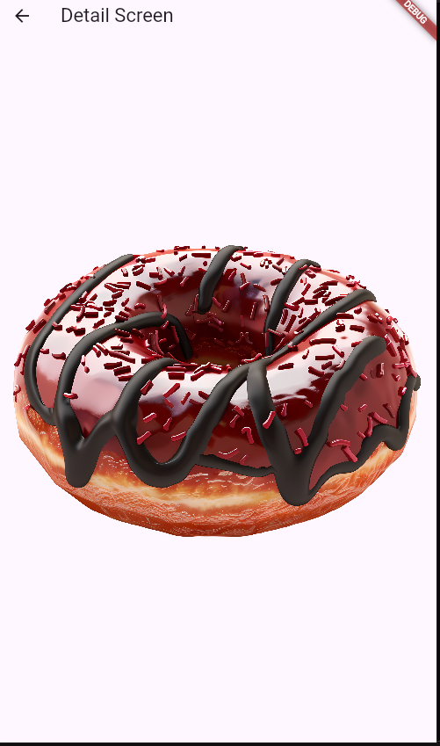

import 'package:flutter/material.dart';

import 'package:flutter/scheduler.dart';

void main() {

   runApp(const MyApp());

}

class MyApp extends StatelessWidget {

  const MyApp({Key? key}) : super(key: key);

  @override

  Widget build(BuildContext context) {

    return MaterialApp(

      title: 'Radial Hero Animation Demo',

      theme: ThemeData(

        primarySwatch: Colors.blue,

      ),

      home: const RadialHeroAnimationScreen(),

    );

  }

}

class RadialHeroAnimationScreen extends StatelessWidget {

  const RadialHeroAnimationScreen({Key? key}) : super(key: key);

  @override

  Widget build(BuildContext context) {

    timeDilation = 5;

    return Scaffold(

      backgroundColor: const Color.fromARGB(255, 25, 24, 24),

      appBar: AppBar(

        title: const Text('Radial Hero Animation Demo'),

      ),

      body: Center(

        child: RadialExpansion(

          photo: 'good.png',

          onTap: () {

            Navigator.push(

              context,

              MaterialPageRoute(builder: (context) => const DetailScreen()),

            );

          },

        ),

      ),

    );

  }

}

class RadialExpansion extends StatelessWidget {

  const RadialExpansion({

    Key? key,

    required this.photo,

    required this.onTap,

  }) : super(key: key);

  final String photo;

  final VoidCallback onTap;

  @override

  Widget build(BuildContext context) {

    return GestureDetector(

      onTap: onTap,

      child: ClipOval(

        child: Hero(

          tag: photo,

          child: Image.asset(

            photo,

            width: 100.0,

            height: 100.0,

          ),

        ),

      ),

    );

  }

}

class DetailScreen extends StatelessWidget {

  const DetailScreen({Key? key}) : super(key: key);

  @override

  Widget build(BuildContext context) {

    return Scaffold(

      appBar: AppBar(

        title: const Text('Detail Screen'),

      ),

      body: Center(

        child: GestureDetector(

          onTap: () {

            Navigator.pop(context);

          },

          child: Hero(

            tag: 'cake.png',

            child: Image.asset(

              'good.png',

              width: 300.0,

              height: 300.0,

            ),

          ),

        ),

      ),

    );

  }

}

